Privacy Preserving Ranked Keyword Search Over Cloud Computing
ABSTRACT
Cloud computing is one of the emerging technologies in today’s world (trend).Cloud computing has envisioned as the next generation architecture of IT enterprise. The flip side to this coin is that cloud storage emerges the security issues of confidentiality, data integrity and data availability. The concept of Third Party Auditor(TPA) is to eliminate the involvement of client through the auditing of whether his data stored in the cloud are indeed intact, which can be important in achieving economies of scale for cloud computing. The task of TPA, on behalf of cloud client is to verify the integrity of the dynamic data stored in cloud. The motive of this paper is to provide data security of cloud in cloud computing using digital signature and elliptic curve cryptography. The Provable data possession scheme is implemented to support the dynamic operation on data. An improvement over the conventional technique is done by allowing the user to search their files in the encrypted database with the help of Ranked keyword search.
Existing System
Symmetric cryptography, which is not suitable for public verification i.e. third party verification. The number of verifications will be static and storage server has to access more blocks per query and this may become increasingly expensive. The fundamental service models in cloud computing are Platform as a Service (PaaS), Infrastructure as a Service (IaaS), Software as a Service (SaaS).Numerous methods have been suggested to solve the problem of data integrity. The third party auditor detects the data on behalf of the client.
Disadvantages
- It is not directly applicable to web services:
- It would not solve the remote server management problem: the administrator would still have to retrieve the contents of all the files to check their integrity
Proposed System
This paper proposes a secure technique where the data of the user can be stored on a public cloud and the user have access rights on his own hands. Through the ranked manner, the user has the capability to find their data and overhead will be saved in the encrypted database. Efficient security is obtained and signature is created using ECC algorithm.
Advantages
- Increasing network bandwidth and reliable
- Clients can now subscribe high quality services from data and software that reside solely on remote data centers.
System Architecture
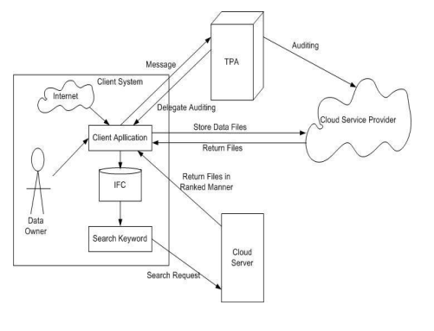
Fig. System architecture

Hardware Requirements:

Processor - Pentium –IV
- Speed - 1.1 GHz
- Ram - 256 MB
- Hard Disk - 20 GB
- Key Board - Standard Windows Keyboard
- Mouse - Two or Three Button Mouse
- Monitor - SVGA
Software Requirements:
- Operating System - Windows XP
- Coding Language - java

